A000-US-NC-Pipe-Wolverine Effigy-Steatite-Cherokee-1500 CE

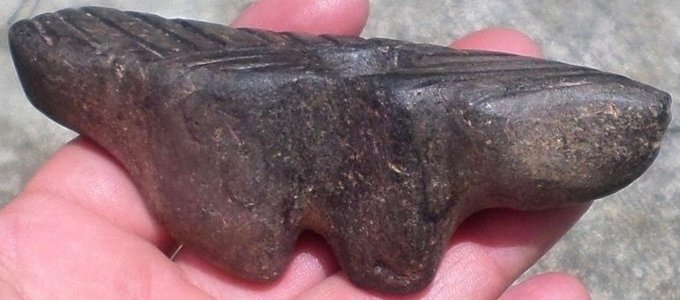

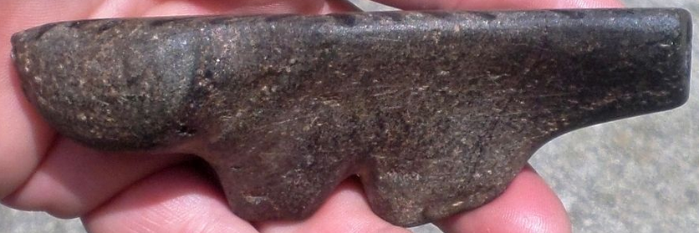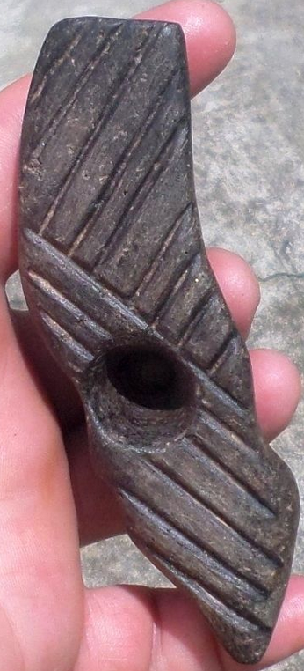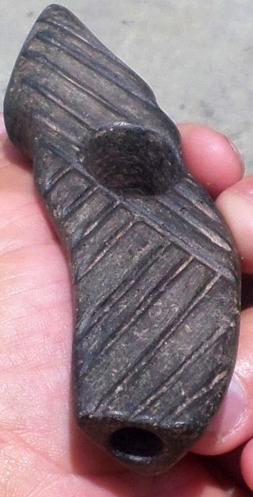

Black Steatite Wolverine Effigy Pipe

Black steatite wolverine effigy pipe that measures 4 5/8” x 1 5/8” x 1 3/8” wide. The top is very flat and has an etched design of 5 lines and 9 lines that covers the entire top. It is in very good condition. This piece is part of an old collection from Little Switzerland, North Carolina.

|  |  |  |
| --- | --- | --- |
| [SP1 Black Steatite Wolverine Effigy Pipe Indian Stone Artifact Native American](http://www.ebay.com/itm/181903906189?_trksid=p2057872.m2749.l2649&ssPageName=STRK%3AMEBIDX%3AIT)  ( 181903906189 )  Estimated delivery Wed, Oct 28  [Add note](javascript:;) | ITEM PRICE:  US $81.00 | **Item SP1 Black Steatite Wolverine Effigy Pipe Indian Stone Artifact Native American Orders 181903906189-0-0**[Leave feedback](http://feedback.ebay.com/ws/eBayISAPI.dll?LeaveFeedbackShow&useridto=tnreliccollector&transactID=0&item=181903906189&_trksid=p2057872.m2749.l2665)[Return this item](http://postorder.ebay.com/Return/ReturnViewSelectedItem?transactionId=0&itemId=181903906189&_trksid=p2057872.m2749.l3185)  [More actions](http://www.ebay.com/myb/PurchaseHistory) |